Signs & Tags, LLC Phone: 1-888-576-8881
www.carlinetags.com (Must dial 1 ) Fax:1-239-236-1457 or 1-888-576-3332
Printable Order Form Revised 8/1/2020
School Name:________________________________________________________
Contact:____________________________________________________________ Address:____________________________________________________________
City:___________________________State:__________________Zip___________Email:______________________________________________________________
Phone:__________________________Fax:_________________________________
 | Description – Item Number  50 Signs per package | Quantity  50 per Pack | Price Per Package | Amount
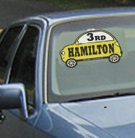 | Car Line Visor Sign – Item #7550  Circle Color: Yellow, Orange, Green or Blue Measures: 9.636 x 6.76 |  | $80.00
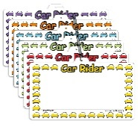 | Car Rider Visor Sign – Item #7575  Circle Color: Yellow, Orange, Green, Blue Red, purple or pink  Measures: 9.75 x 5.75 |  | $70.00
50 Backpack Tags Per package Quantity Price Amount
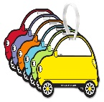 | Car Line Backpack Tag - Item 8020  Circle Color: Yellow, Orange, Green, Blue, purple or Red |  | $45.00
 | School Bus Backpack Tag - Item 8050  (Side View) - Circle Color Choice  Yellow, Red, Green, Blue, Orange or Purple |  | $45.00
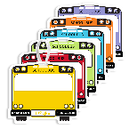 | School Bus Backpack Tags – Item 8010  Color Choice: Yellow, Red, Green, Blue, Orange  or Purple |  | $45.00

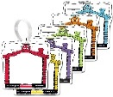 | Before/After Backpack Tag - Item 8040  Circle Color: Yellow, Orange, Blue, Green,  Red or Purple |  | $45.00
 | Walk or Wheel Backpack Tag – Item 8030  Circle Color: Yellow, Orange, Green, Red or Purple |  | $45.00
 | Subtotal
 | Shipping Charges – Based on weight of package
 | Total
Pay with Credit Card#:______________________________________Exp_______________
Pay with PO Number __________________________Signature:_______________________
Please fax or scan your completed order to:
Signs & Tags, LLC Phone Number: 1-888-576-8881
PO Box 1815, Sparta, NJ 07871 Fax Number: 1-888-576-333
Scan to Email: sales@carlinetags.com Website: http://www.carlinetags.com

